Map of Houston

1. Harris county

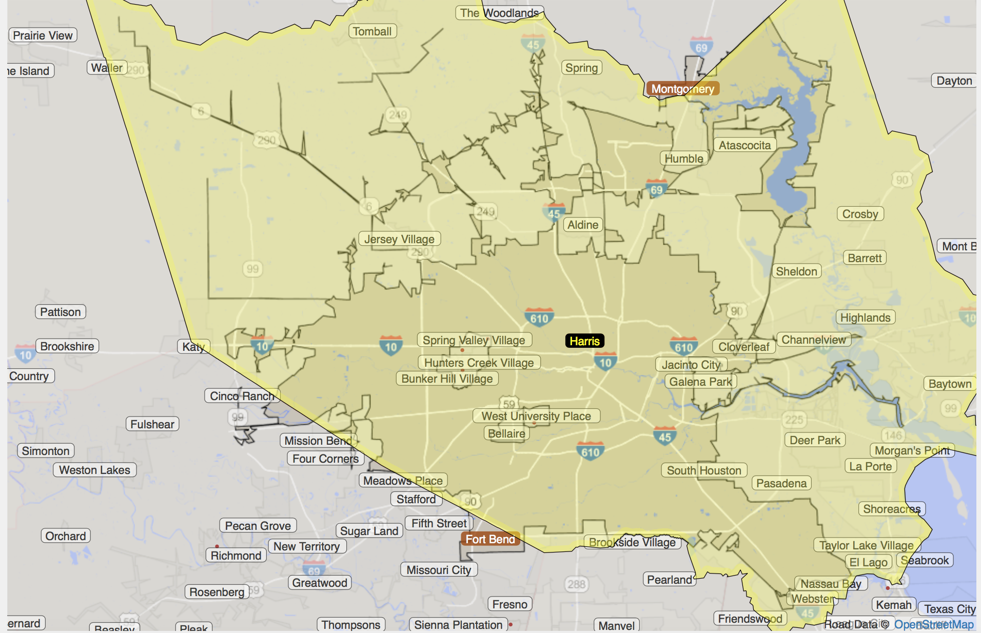

1. Houston city
2. Houston area (Metro Area)

<http://statisticalatlas.com/metro-area/Texas/Houston/Overview>

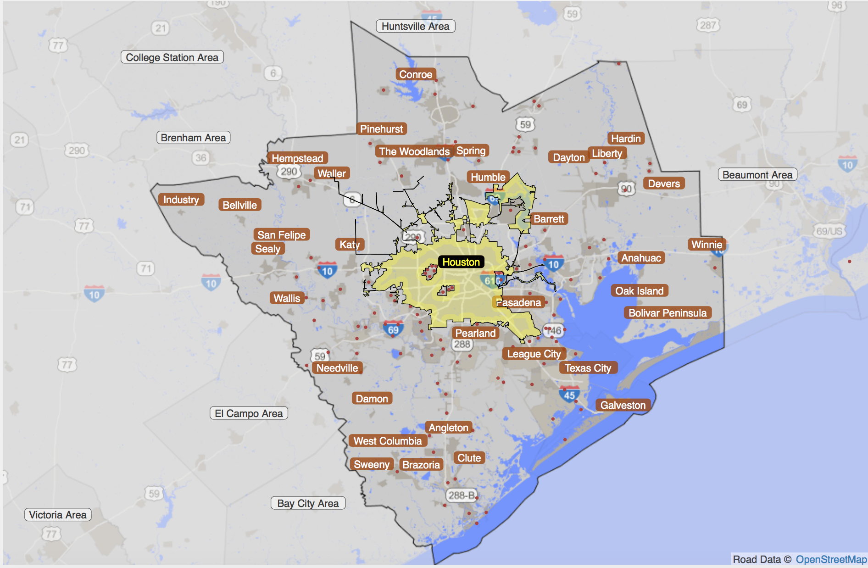

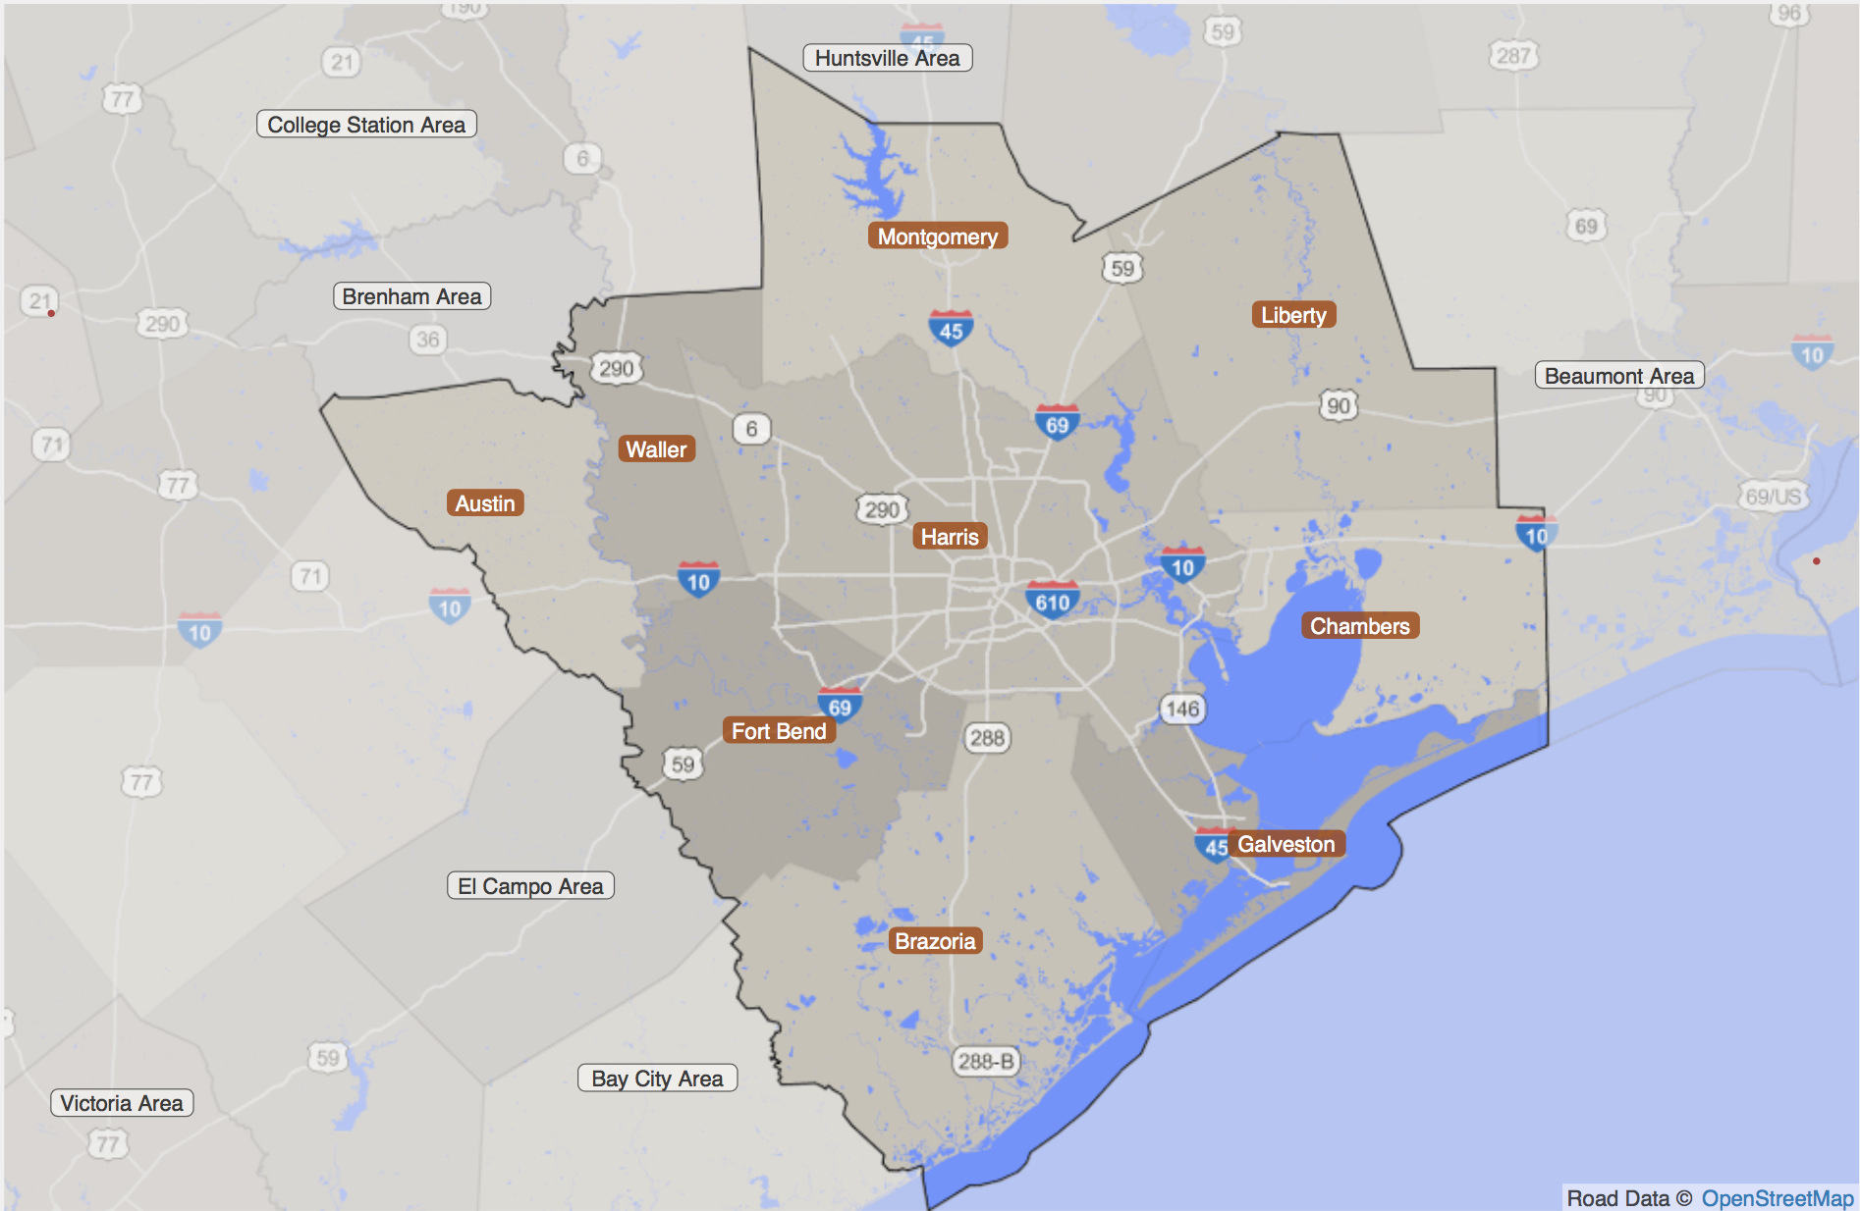

The total population in Houston area is 6,063,540, and there are 2,068,518 households.

Houston area (Metro area) has 9 counties, and they are:

Montgomery (339), Liberty (291), Chambers (071), Galveston (167), Harris (201), Waller (473), Austin (015), Fort Bend (157), Brazoria (039)

<https://factfinder.census.gov/faces/nav/jsf/pages/searchresults.xhtml?refresh=t>

Marginal distribution available in County level:

1. Age by sex
2. Marital status
3. Education attainment
4. Individual income in the past 12 month
5. Commuting characteristics by sex: means of transportation to work; place of work; time leaving home to go to work; travel time to work; vehicle available;

Map census tract to puma, filename: “2010_Census_Tract_to_2010_PUMA.txt”

Land Use:

Aggregate data for population